2019 Rumble on the Red
Wrestling Championships
HIGH SCHOOL EVENT SCHEDULE

Hosted by: Metro Tournament Committee/MSUM Wrestling/West Fargo HS
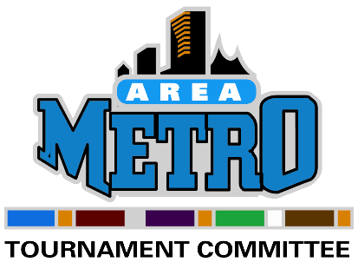
FARGODOME
December 27th & 28th, 2019
www.fargorumble.com

High School Varsity/JV EVENT SCHEDULE
Thursday, December 26th
1PM-6PM Registration in East Lobby of FARGODOME
1PM-7PM Mats Open for Workouts at FARGODOME

Friday, December 27th
6:45 AM Doors Open
7:30 AM Weigh-ins & Skin Check (2 pound growth allowance per NDHSAA rules)
9:10 AM Coaches Meeting (Fargodome Team Room-bottom of escalator)
10:00 AM Wrestling Starts
We will possibly run semi-finals on Friday depending estimated time of completion.

Saturday, December 28th
6:45 AM Doors Open
7:30 AM Weigh-ins & Skin Checks (3 pound growth allowance)
9:00 AM Wrestling Starts through finals
There is no set time for finals until we know numbers

IMPORTANT TOURNAMENT INFORMATION

- All times are tentative
- If a wrestler does not make weight, he is scratched from the tournament
- Wrestling will be going continuously on Friday and there will be no breaks
- All JV matches will be 1.5-1.5-1.5 and consolation Varsity matches will be 1-2-2
- NO team camps on the Fargodome Floor
- Admission: Adults $25-two day pass/$15-one day pass, Student $12-two day pass/$7-one day pass, Under 6-Free

December 7th – 22nd
- Initial Team Line-ups (V and JV) must be added to Trackwrestling.com
- An email will be sent to each coach with login and password info for Trackwrestling.com.

December 26th
  - NOON Deadline – For changes and substitutions made by the coach online via Trackwrestling.com. Additional changes can be made at registration.
- 1PM to 6PM – Team Packets/Name Badges MUST be picked up during registration hours
- 6PM Deadline – ALL changes MUST be made. NO EXCEPTIONS!
  - If a wrestler is entered in the wrong weight class or division after 6PM, he has to compete at entered weight or is scratched from the tournament.

For Questions: Contact Steve Saxlund (701) 371-6703 (cell) or email: steve@3timegear.com

